C

HAPTER 1

INTRODUCTION

Objective

The aim of this project is to create a secure, dependable, and easy-to-use Payroll Management System that organizes and automates the payroll operations of an organization in an efficient manner. The system is aimed at overcoming the drawbacks of manual payroll processing, including human mistake, time-consuming processing, absence of transparency, and trouble in keeping historical records. Through digital processing of employee salaries, this system will ensure timely payment and accuracy of employees' pay, handle tax deductions, and provide statutory compliance reports as required by the government.
The system also aims to keep detailed records of employee information such as personal details, salary structure, attendance, leaves, bonuses, deductions, and other transactions related to payroll. It ensures accuracy and consistency in calculating net salaries by using automated calculations. The system also makes payslip generation and distribution easy, thus enabling the payroll process to be transparent and available to employees.
Furthermore, the project will improve the decision-making ability of the HR and finance teams through real-time reporting and analytics. The solution features multi-user support with role-based security to restrict sensitive data and make it available only to approved users. Generally, the aim is to automate payroll processing, minimize administrative time, increase data integrity, and help in efficient human resource management within the organization.

Overview
A Payroll Management System is an essential software solution used by organizations to manage and streamline all payroll-related tasks. It automates the process of salary calculation, tax deductions, leave management, attendance tracking, payslip generation, and compliance with labor and tax regulations. The system eliminates the need for manual calculations and paperwork, thus reducing the chances of human error and improving efficiency.
This project focuses on developing a computerized Payroll Management System that stores and manages employee information and uses it to accurately calculate monthly salaries based on predefined rules and conditions. It takes into account various salary components such as basic pay, allowances, deductions, bonuses, and overtime, and applies the necessary statutory deductions like income tax, provident fund (PF), and employee state insurance (ESI).
The system is designed to be user-friendly and secure, with different access levels for administrators, HR personnel, and employees. Admin users can add or modify employee details, update salary structures, and generate reports. Employees can view their personal salary information and download payslips.
By automating routine payroll tasks, the system helps organizations save time, reduce administrative burden, ensure legal compliance, and maintain transparency in financial dealings with employees. It also provides timely and accurate payroll reports that are useful for audits, financial planning, and HR decision-making.
This Payroll Management System demonstrates the application of database management, user interface design, and business logic integration in building an effective real-world software solution.

1.3 SQL and Database Concepts

A database is a structured collection of data that can be easily accessed, managed, and updated. In the context of a Payroll Management System, the database plays a crucial role in storing employee records, salary details, attendance logs, tax information, and other payroll-related data.
Basic SQL and Database Concepts :
- Database: ::
A database is an organized collection of data, generally stored and accessed electronically. It allows efficient retrieval, insertion, and manipulation of data using a Database Management System (DBMS).
- DBMS:
DBMS is software that interacts with end users, applications, and the database to capture and analyze data. Examples include MySQL, Oracle, and SQL Server.
- SQL:
SQL is the standard language used to interact with relational databases. It is used to perform tasks such as inserting, updating, deleting, and retrieving data from a database.
- Tables:
A table is a collection of related data entries, consisting of rows and columns. Each row is called a record, and each column is a field.
- Primary:
A primary key is a unique identifier for each record in a table. It ensures that each row in a table is uniquely identifiable.
- Foreign:
A foreign key is a field in one table that refers to the primary key in another table. It is used to establish a relationship between two tables.
- Normalization:
The process of organizing data in a database to avoid redundancy and ensure data integrity. It involves dividing large tables into smaller, related tables.
- Data:
SQL supports various data types such as INT, VARCHAR, DATE, and FLOAT, which define the type of data that can be stored in each column.
- Basic SQL Commands:
  - SELECT: Retrieves data from one or more tables
  - INSERT: Adds new records to a table
  - UPDATE: Modifies existing records
  - DELETE: Removes records
  - CREATE: Defines a new table or database structure
Project-Related Database Concepts (Payroll Management System):
In the Payroll Management System, the following database structure and concepts are implemented:
- Employee Table
Stores personal and job-related information of employees.
Fields: employee_id (PK), name, department, designation, join_date, salary, bank_account, etc.
- Attendance Table
Keeps daily attendance records used for salary computation.
Fields: attendance_id (PK), employee_id (FK), date, status (Present/Absent/Late), working_hours
- Salary Table
Records monthly salary details after calculation.
Fields: salary_id (PK), employee_id (FK), basic_salary, allowances, deductions, net_salary, payment_date
- Leave Table
Manages employee leave applications and balances.
Fields: leave_id (PK), employee_id (FK), leave_type, start_date, end_date, status
- Tax and Deduction Table
Maintains records of tax calculations and other deductions.
Fields: tax_id (PK), employee_id (FK), income_tax, PF, ESI, other_deductions
- User Access Table (if system has login)
Defines roles for system users such as Admin, HR, and Employee.
Fields: user_id (PK), username, password, role
The database is normalized to at least 3NF (Third Normal Form) to eliminate redundancy and ensure relational integrity between tables.
SQL queries are used extensively for:
- Fetching employee salary details
- Calculating net pay
- Generating monthly reports
- Managing user login and roles

CHAPTER 2
PROJECT METHODOLOGY

2.1Proposed Work
The proposed Payroll Management System aims to overcome the limitations of manual payroll processing by implementing an automated, accurate, and secure software solution. This system is intended to simplify the management of employee salary calculations, tax deductions, attendance tracking, leave management, and report generation. The goal is to reduce administrative overhead, minimize human error, and ensure timely and compliant payroll processing.
Problem Statement
In many organizations, payroll management is still handled manually or through inefficient spreadsheets. This results in:
- Inaccurate salary calculations
- Delayed salary payments
- Difficulty in tracking attendance and leave
- Lack of proper tax deductions and compliance
- Poor data security and access control
The proposed system addresses these issues by providing a centralized and automated platform for payroll operations.
Objectives of the Proposed System
- Automate salary computation based on employee attendance, leaves, and defined salary structure.
- Maintain a comprehensive employee database with secure and role-based access.
- Record attendance and leave data to influence salary calculations.
- Generate payslips and salary reports accurately and efficiently.
- Calculate statutory deductions such as PF, ESI, and income tax.
- Provide a user-friendly interface for administrators, HR, and employees.
- Allow multi-user access with secure login and role segregation.
- Facilitate data backups, easy report generation, and audit trails.

Features of the Proposed System
- Employee Management: Add, update, and delete employee records.
- Attendance Module: Daily attendance input and tracking.
- Leave Management: Leave application, approval, and balance tracking.
- Payroll Calculation: Auto-calculation of gross salary, deductions, and net salary.
- Payslip Generation: Instant payslip creation in printable format.
- Tax Management: Automatic deduction and record of PF, ESI, and income tax.
- Reports Module: Monthly and annual payroll reports, tax reports, and audit logs.
- User Management: Secure login with Admin and Employee roles.
Proposed System Architecture
The system will follow a three-tier architecture:
- Presentation Layer: The user interface, built using a frontend framework (e.g., HTML/CSS with PHP or Python GUI).
- Application Layer: Business logic to process payroll operations, written in a programming language like Python, Java, or PHP.
- Database Layer: Relational database (e.g., MySQL or SQLite) for storing all system data securely.

2.2 Block Diagram

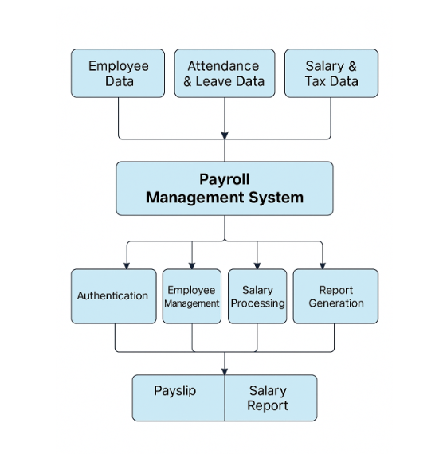

CHAPTER 3
MODULE DESCRIPTION

3.1 Module 1 Heading

3.2 Module 2 Heading

3.3 Module 3 Heading

3.4Module 4 Heading

3.5Module 5 Heading

CHAPTER 4
CONCLUSION AND FUTURE ENHANCEMENT

APPENDIX A (Project Source Code)
APPENDIX B (Paste Screenshots with title and description)

REFERENCES:

(It may be any Java Books (Refer Syllabus), websites, YouTube links etc..)

